1.Write a program to print Fibonacci series using recursion

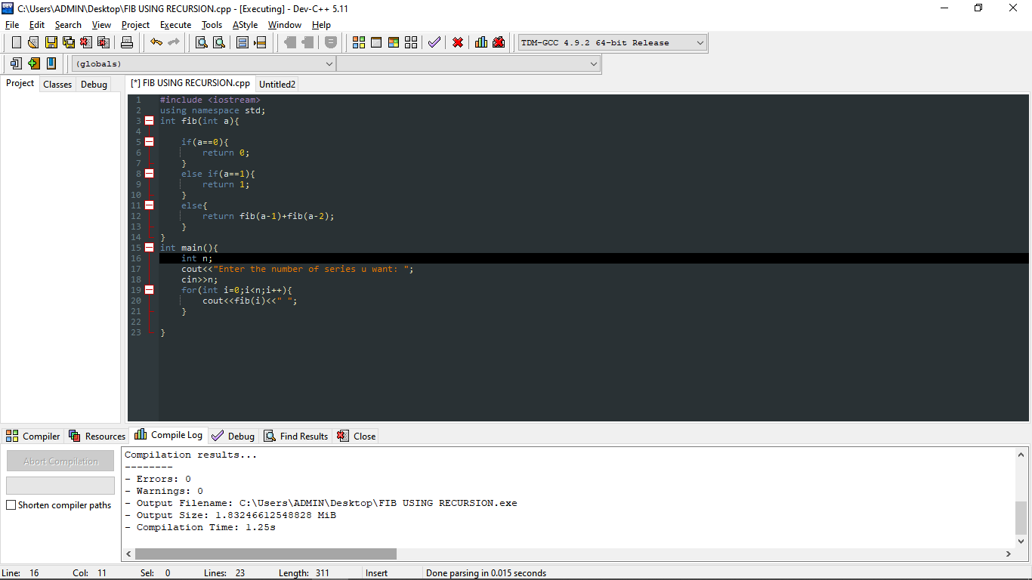

OUTPUT:-

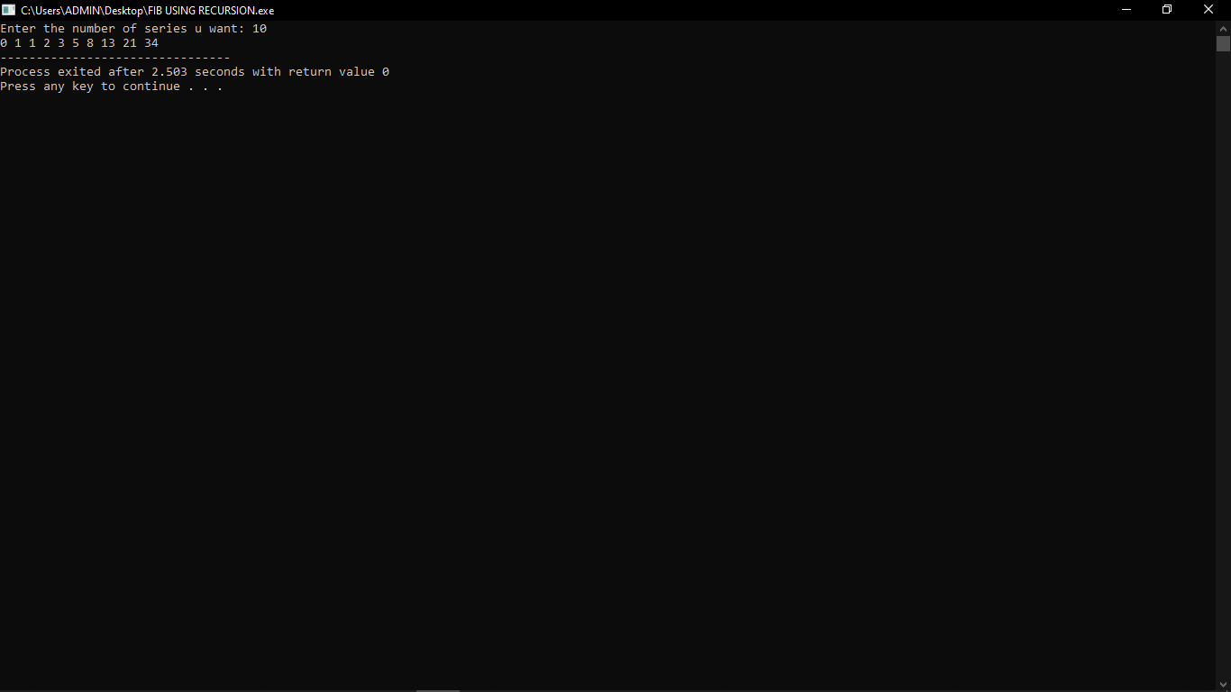

2.Write a program to check the given no. is Armstrong or not using recursive function

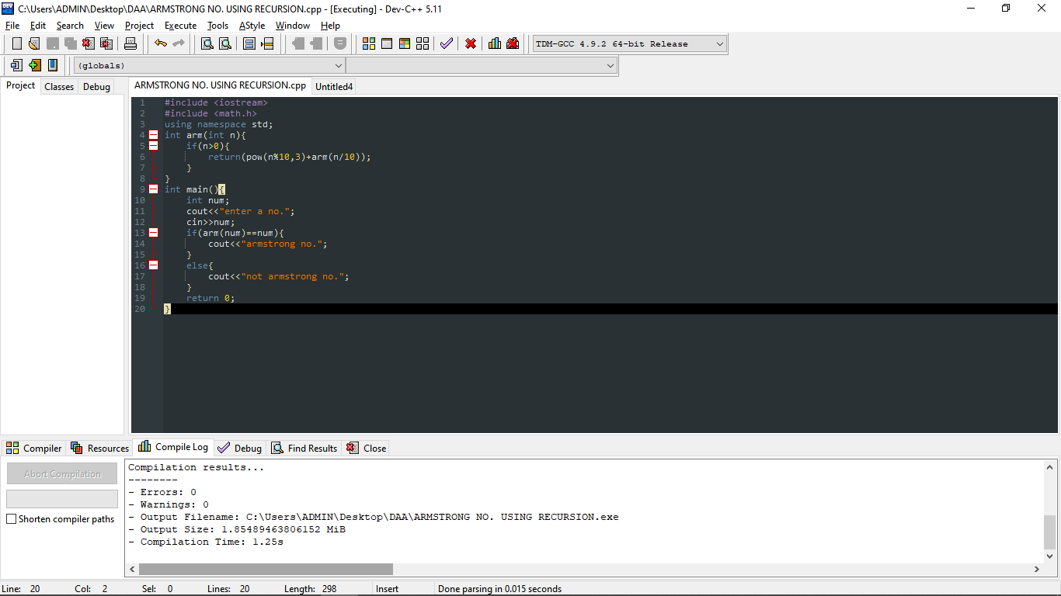

OUTPUT:-

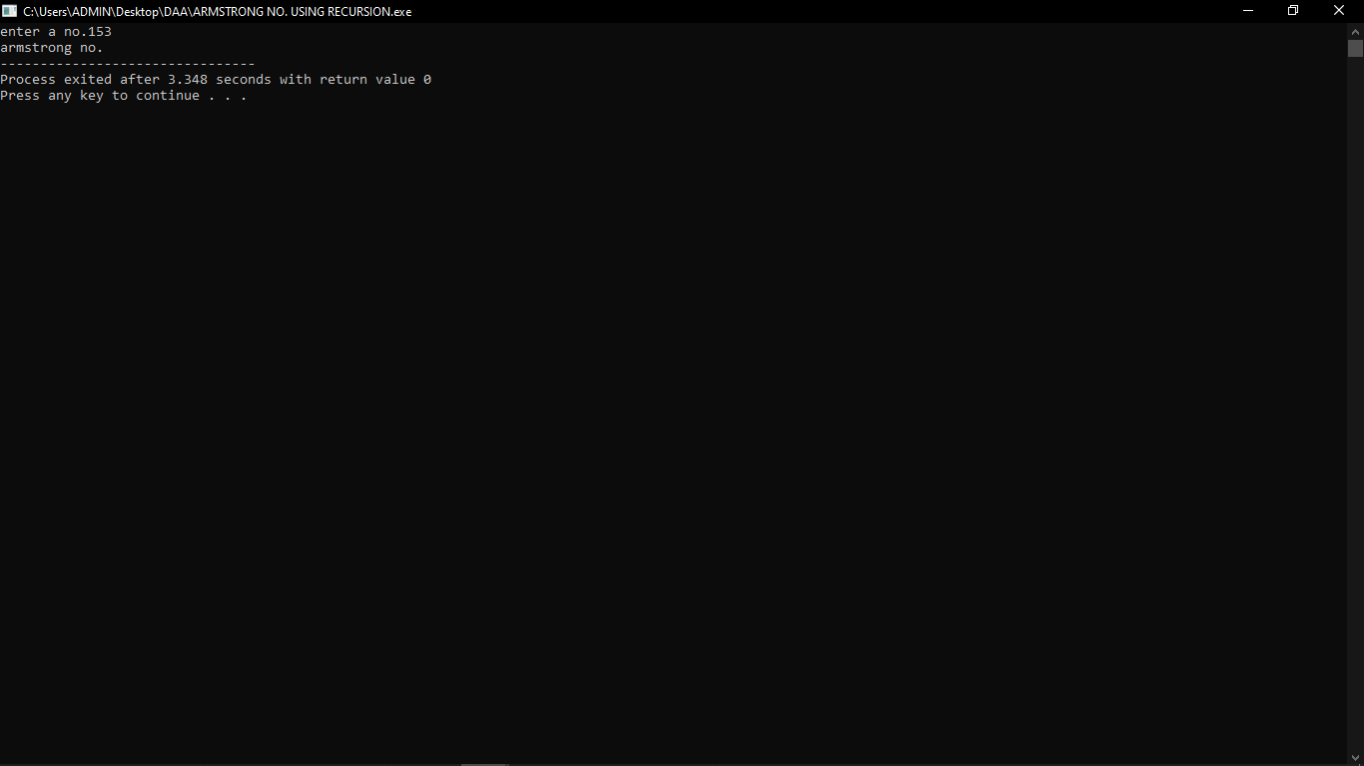

3.Write a program to find GCD of two number using recursive factorization

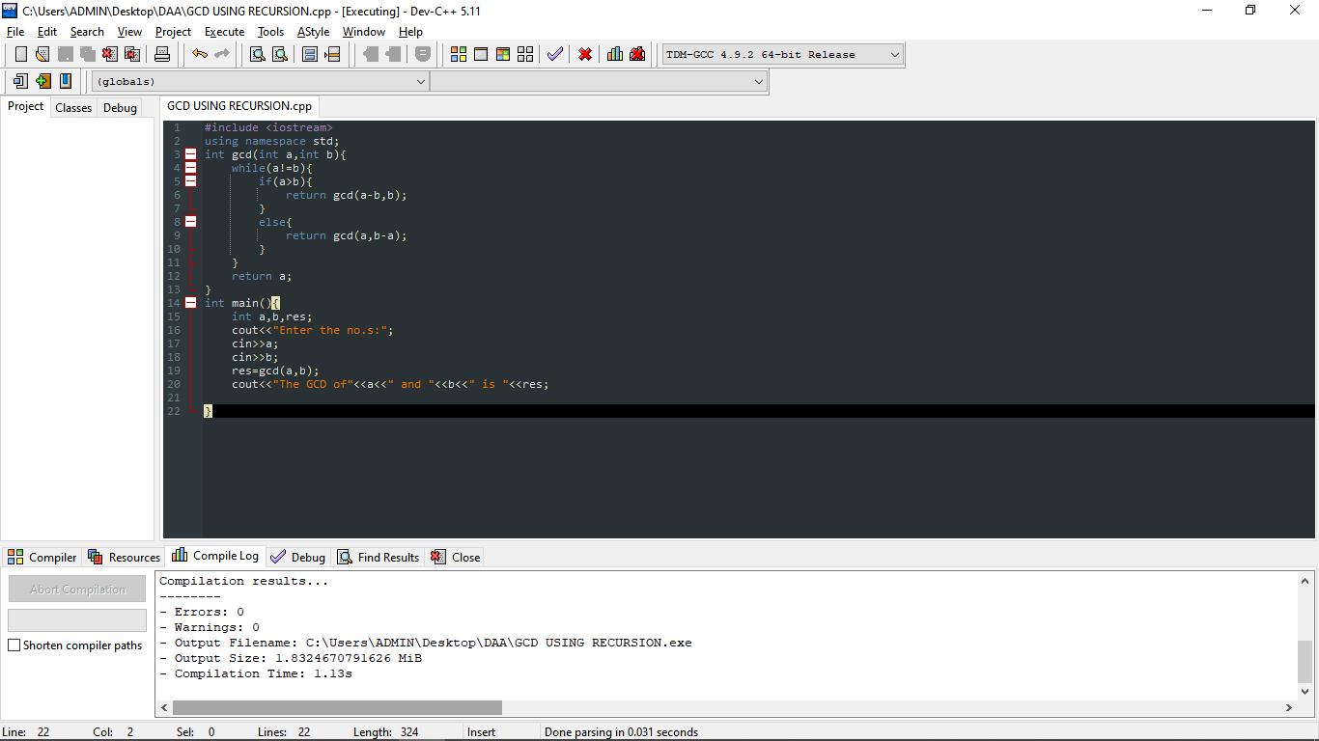

OUTPUT:-

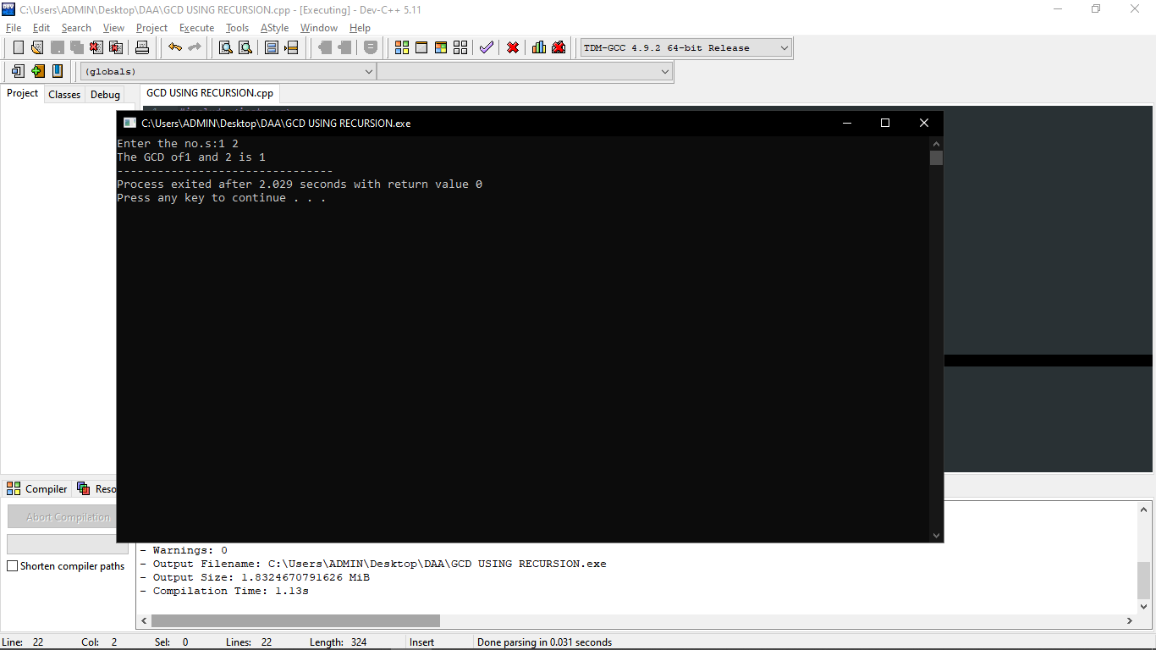

4.Write a program to get the largest element in an array.

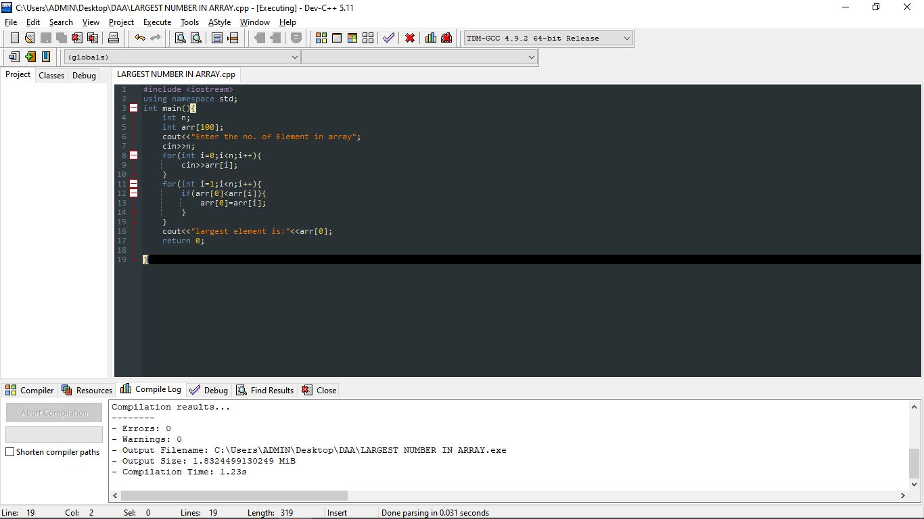

OUTPUT:-

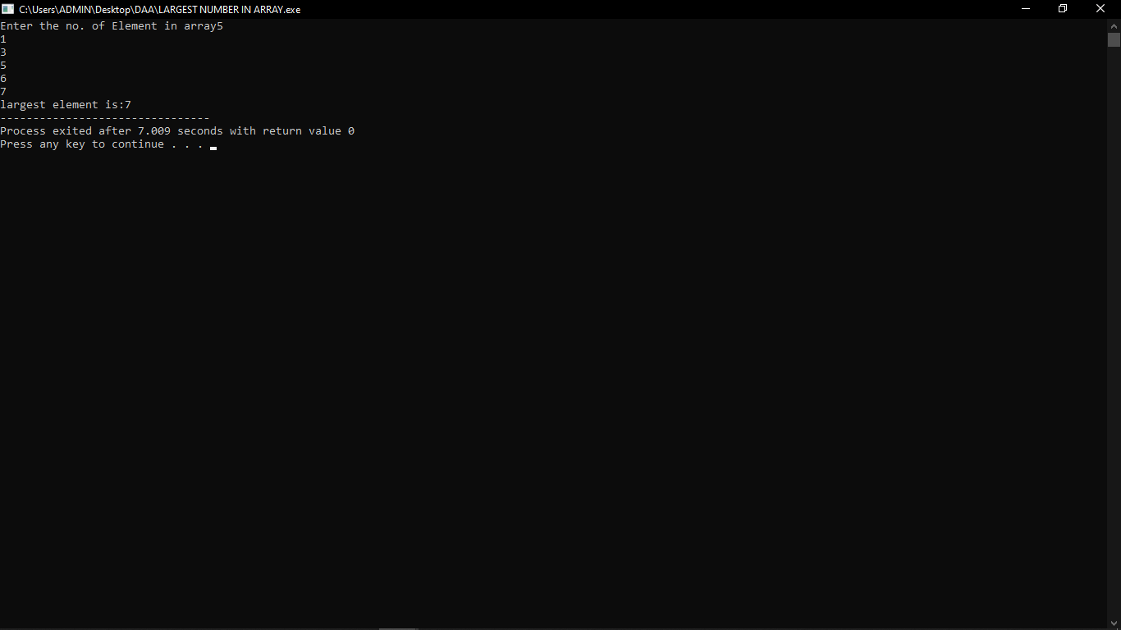

5.Write a program to find the factorial of a number using recursion.

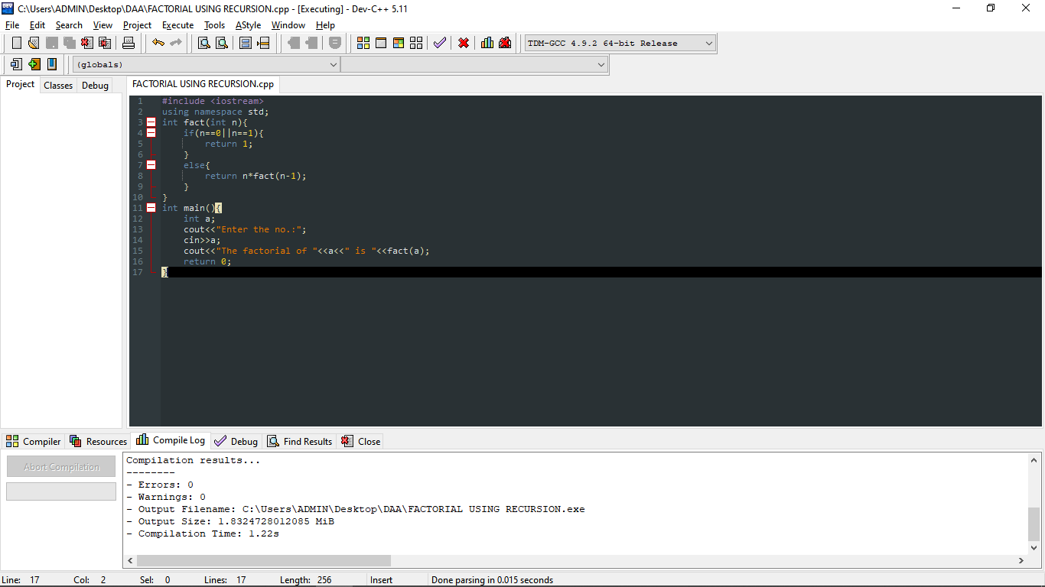

OUTPUT:-

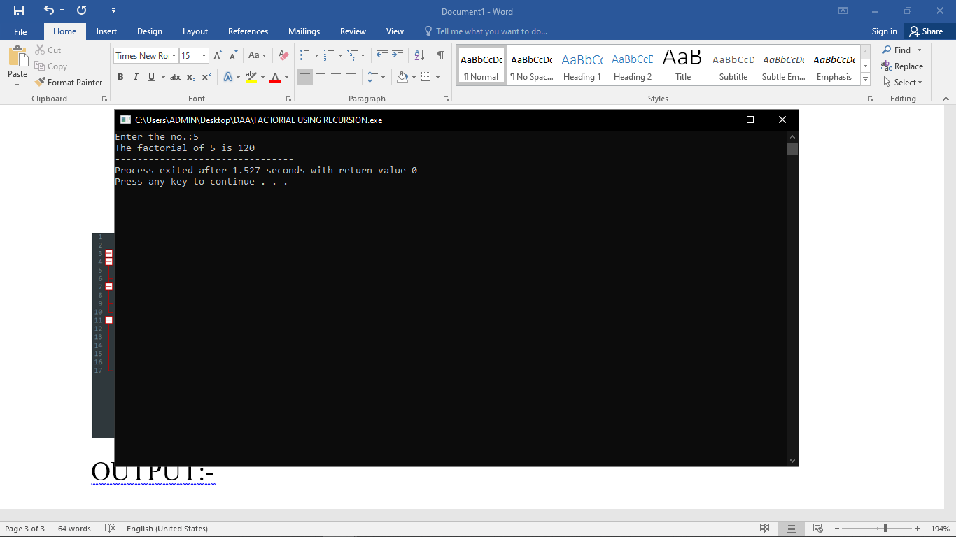

6.Write a program to copy one string to another using recursion.

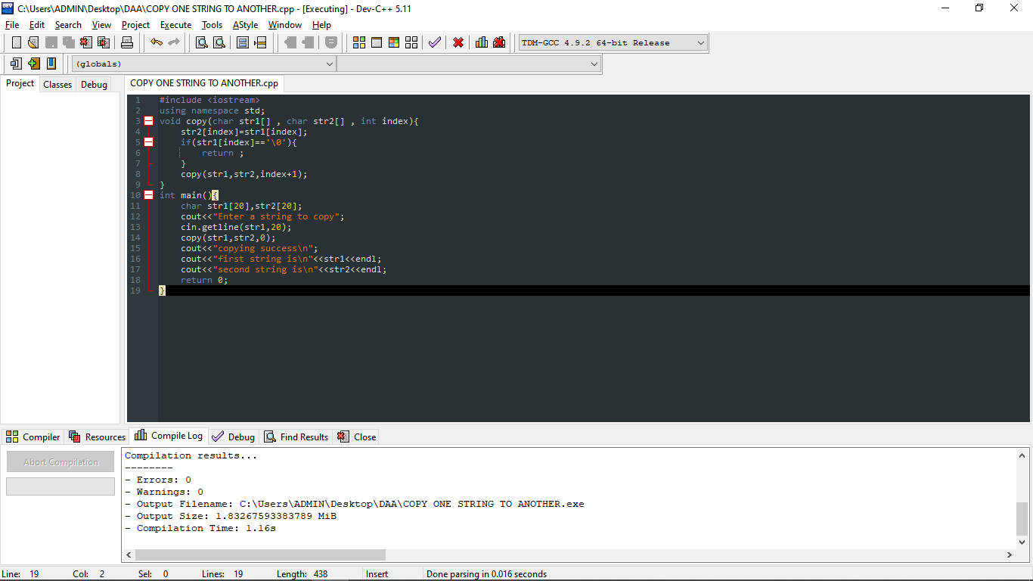

OUTPUT:-

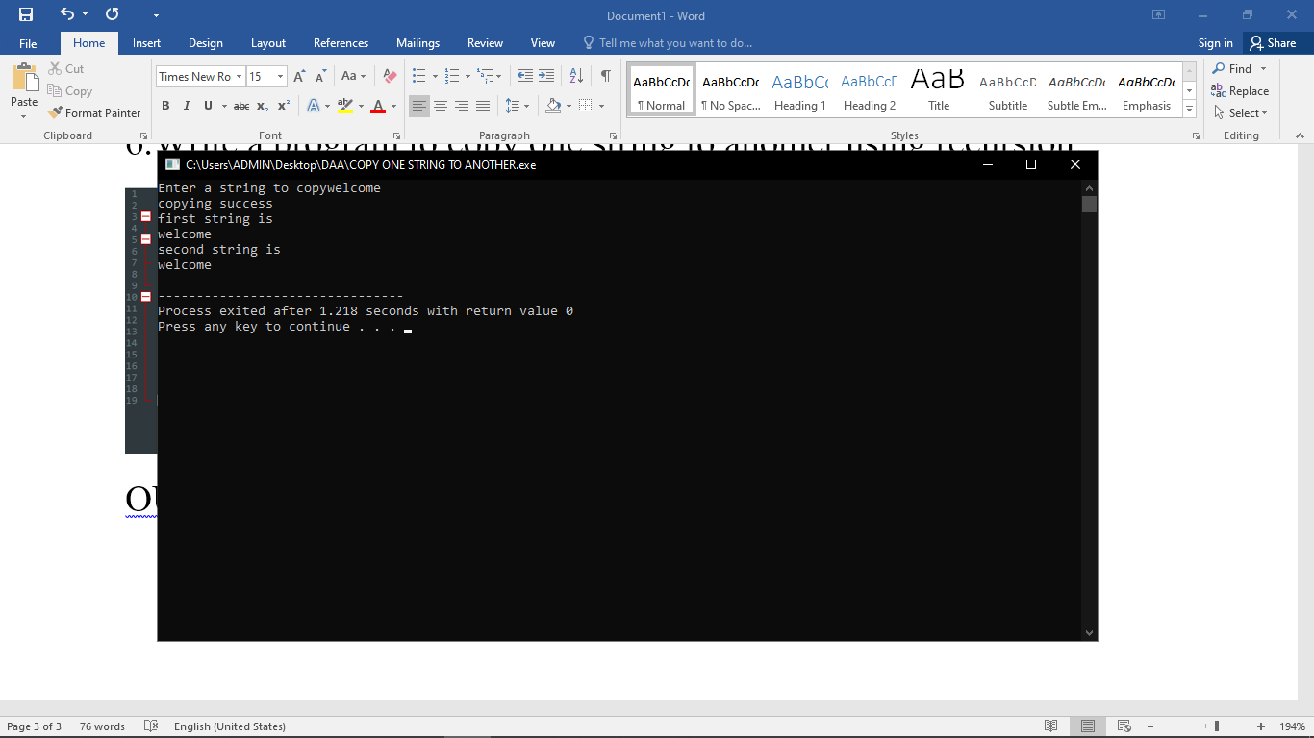

7.Write a program to reverse a string using recursion.

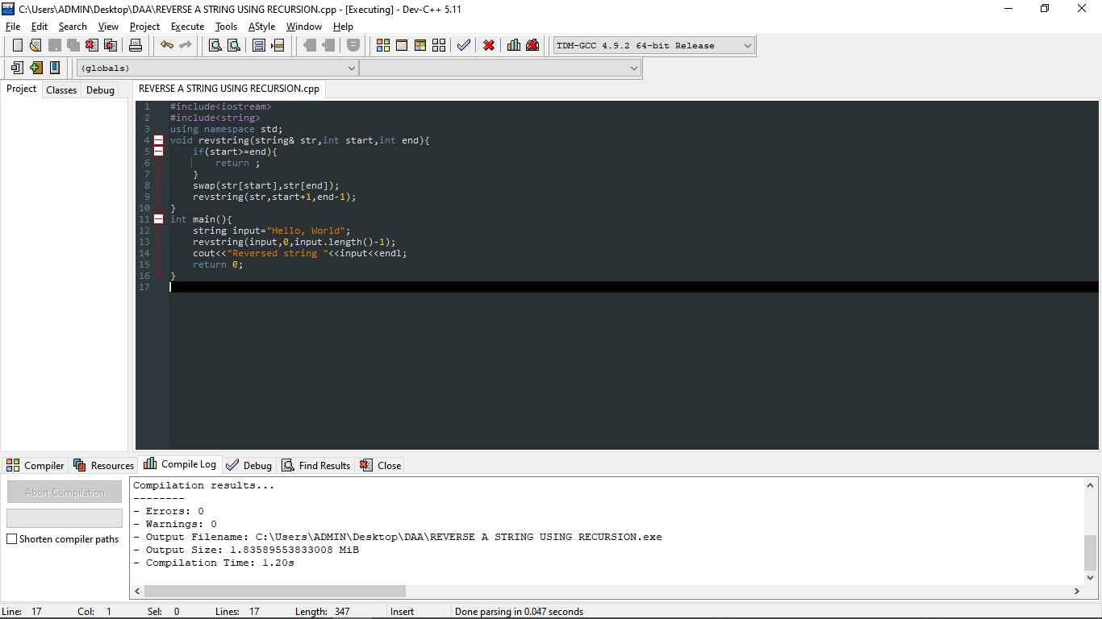

OUTPUT:-

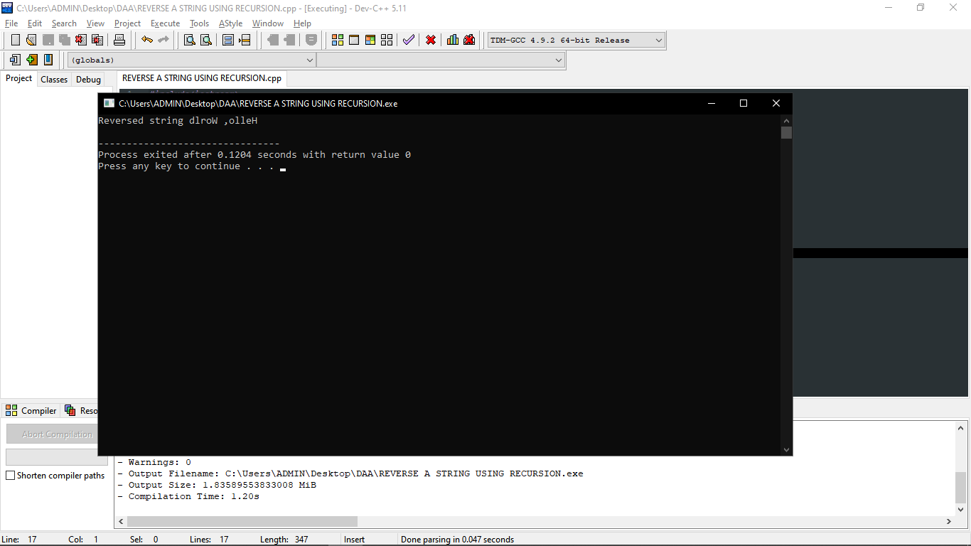

8.Write a program to generate all the primes using recursion.

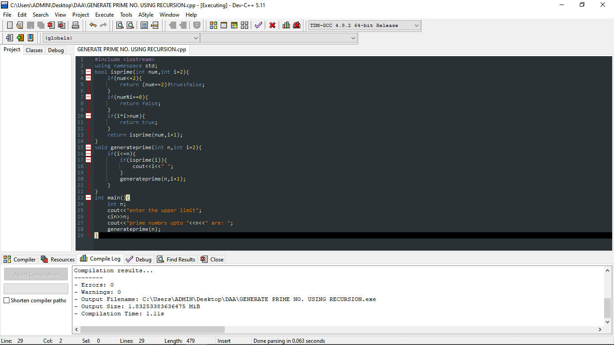

OUTPUT:-

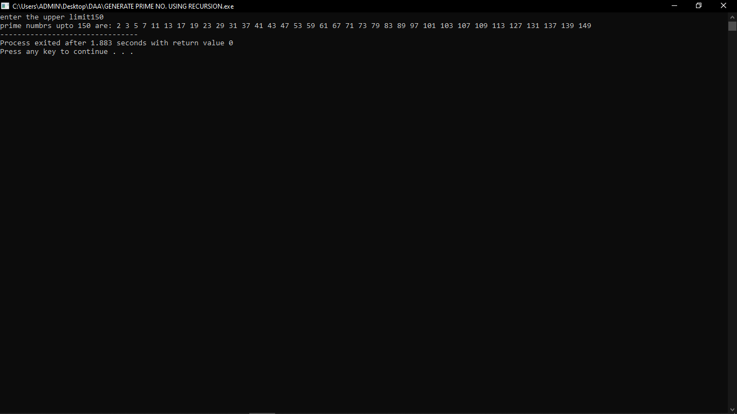

9.Write a program to check whether a number is prime or not using recursion.

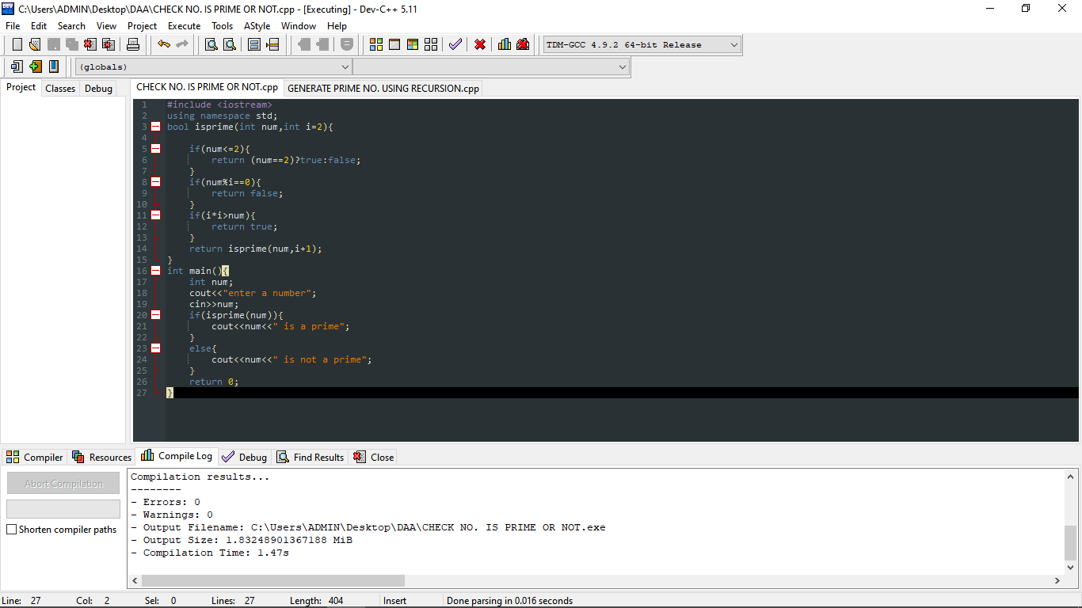

OUTPUT:-

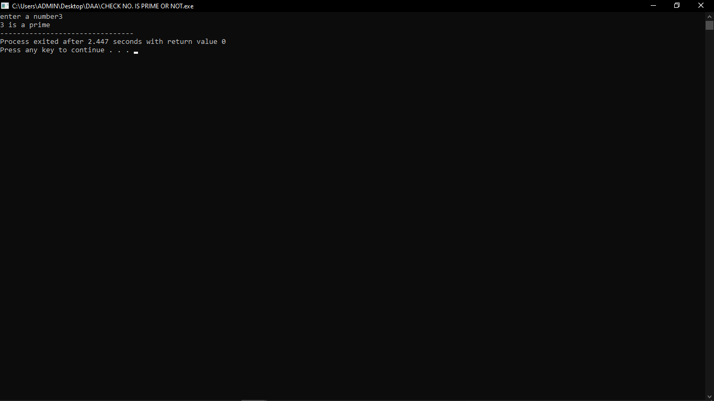

10.Write a program to check whether a string is palindrome or not using recursion.

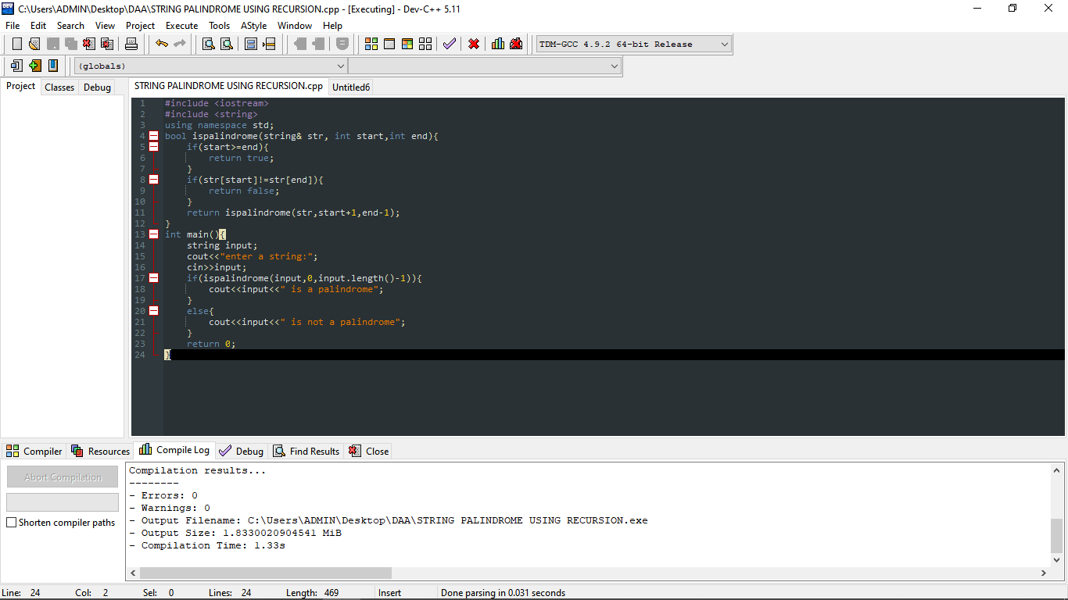

OUTPUT:-

